1. First step is need to install anaconda for windows u can download it from

https://www.anaconda.com/products/individual

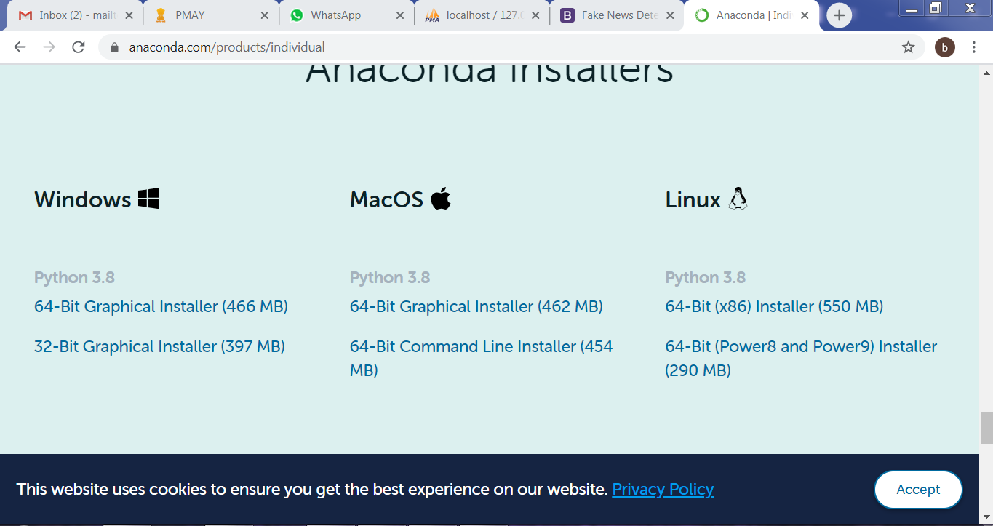

After installing anaconda open command prompt and type here

>python

It gives set of instructions after that install the following commands

1. Pip install Django
2. Pip install mysqlclient

Now open our project in visual studio code

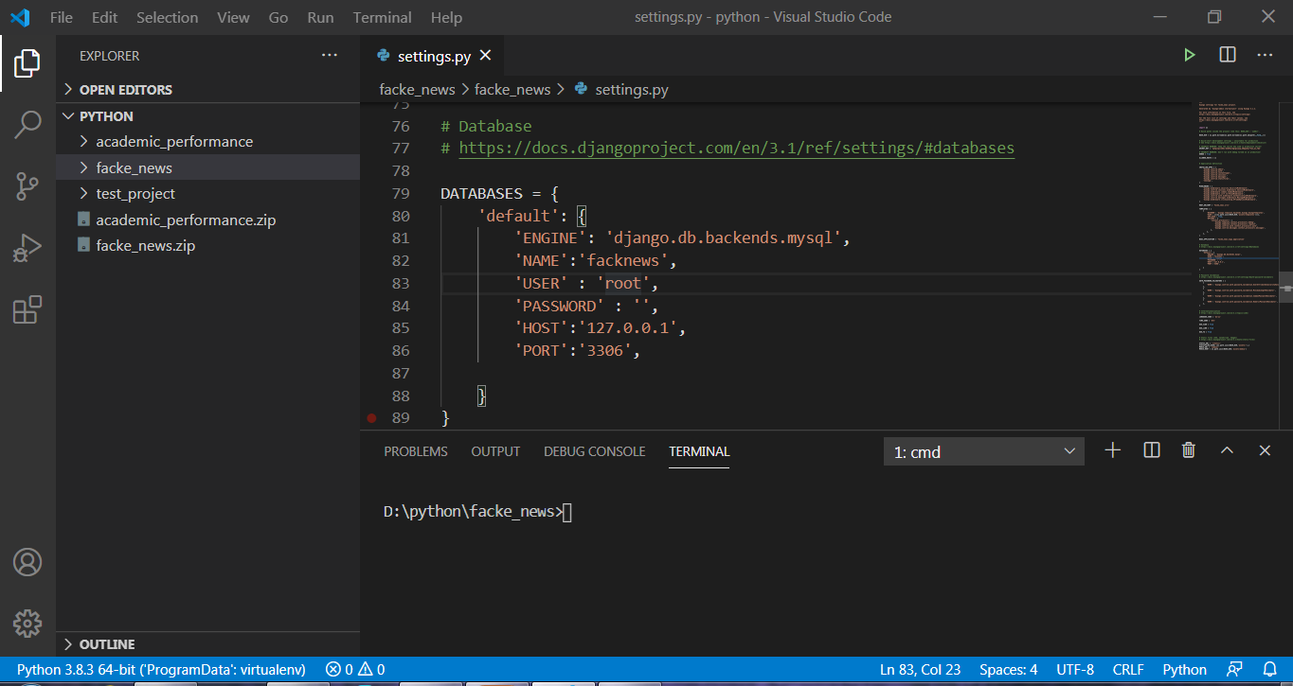

Now need to type the following cmd

python manage.py runserver

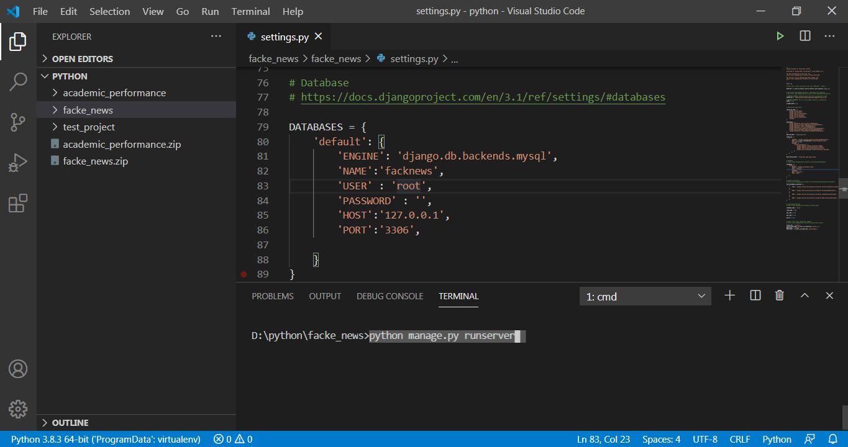

Click enter in cmd prompt

